London Metropolitan University Sports Therapy Clinic
Patient Name: |  |  | Patient 5 – Male |  |  |  |  |  |  |  |  |  |  |  |  |  |  |  |  |  |  |  |  |  |  |  |  |  |  |  |  |  |  |  |  |  |  | DOB: |  |  |  |  |  | 21/06/87
Occupation: |  |  | Delivery Driver |  |  |  |  |  |  |  |  |  |  | Activity level:  1 2 3 4 5 6 7 8 9 10 |  |  |  |  |  |  |  |  |  |  |  |  |  |  | Sedentary Athletic
Main Problem:
Lx L sided pain and L leg ache

Body Chart
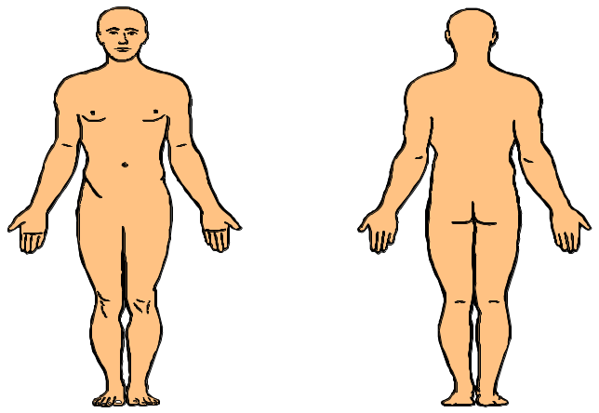 |  |  |  |  |  |  |  |  |  |  |  |  |  |  |  |  |  | P1 5/10  Deep  Intermittent  Strong ache feeling  P2 2/10  Dull ache in upper posterior thigh
General Health/Meds: |  |  |  |  |  |  |  |  |  |  |  |  |  |  |  |  |  |  |  |  |  |  |  | Previous injuries/Medical History/Operations/Accidents:
Maximal paracetamol daily – Not much effect  Smoker  Overweight |  |  |  |  |  |  |  |  |  |  |  |  |  |  |  |  |  |  |  |  |  |  |  |  | Previous Lx disc bulge 4 years ago. Told he will always have back problems.
Sport/Exercise (type, level, position, competition, training, intensity, frequency, duration):
Only enjoys weight training at the gym but has stopped since injury due to wanting to protect back.

History of Present Condition: |  |  |  |  |  |  |  |  |  |  |  |  |  |  |  |  |  |  |  |  |  |  |  | Previous Treatment/MRI/X-RAY:
Started 6/12 ago after lifting a heavy box at work, initially improved with rest but has returned and worsened over the last 4/52  Attending appointment for massage, as “it help last time”. |  |  |  |  |  |  |  |  |  |  |  |  |  |  |  |  |  |  |  |  |  |  |  | MRI 4 years ago to diagnose Lx disc bulge and was referred for physio for massage.
Aggravating: |  |  |  |  |  |  |  |  |  |  |  |  |  |  |  |  |  |  |  |  |  |  |  | Easing:
Bending |  |  |  |  |  |  |  |  |  |  |  |  |  |  |  |  |  |  |  |  |  |  |  | Heat and rest – 1 hour
Prolonged standing – 20 mins |  |  |  |  |  |  |  |  |  |  |  |  |  |  |  |  |  |  |  |  |  |  |  | Sitting – 10 mins
24-Hour Cycle: |  |  |  |  |  |  |  |  |  |  |  |  |  |  |  |  |  |  |  |  |  |  |  | Sleep:
OW – No pain  OR – Stiffness  During day – Worsens with prolonged activity  Evening – Can be painful after work |  |  |  |  |  |  |  |  |  |  |  |  |  |  |  |  |  |  |  |  |  |  |  | Pattern – Poor sleep  Wakes with symptoms – No  Pillows/position – 1 pillow, lays on L side
London Metropolitan University Sports Therapy Clinic
Patient  Name: |  | Patient 5
Objective Assessment:
Observation: |  |  |  |  |  |  |  |  |  |  |  |  |  |  |  |  |  |  |  | Touch & Palpation
Tight erector spinae bilaterally  Overweight |  |  |  |  |  |  |  |  |  |  |  |  |  |  |  |  |  |  |  | Muscle spasm and tenderness around L side lower back
Physiological |  |  |  |  |  |  |  |  |  |  |  |  |  |  |  |  |  |  |  |  |  |  |  |  |  |  |  | Accessory (only if joint problem suspected)
Area: |  | Action |  | Active |  |  |  |  | Passive |  |  |  | Resisted |  |  |  |  |  |  |  |  |  |  |  |  |  |  | Area |  |  |  |  |  |  |  | Accessory |  |  |  |  |  |  |  |  |  |  | Pain/Stiffness/NAD/ROM
Lx |  | Flexion |  | -ROM |  |  |  |  | NAD |  |  |  | Weak
  Lx
  T11
  12
  L1
  2
  3 |  |  | R>P |  | R>P
  4 | P>R |  | R>P |  | R>P
  5 | P>R |  | P>R |  | R>P
  S1
 |  | Extension |  | Pain |  |  |  |  | NAD |  |  |  | Weak
 |  | L rotation |  | NAD |  |  |  |  | NAD |  |  |  | Weak
 |  | R rotation |  | NAD |  |  |  |  | NAD |  |  |  | Weak
 |  | L side flexion |  | Pain |  |  |  |  | NAD |  |  |  | Weak
 |  | R side flexion |  | NAD |  |  |  |  | NAD |  |  |  | Weak
Muscles: |  |  |  |  |  |  |  |  |  |  |  |  |  |  |  |  |  |  |  |  | Special questions (before assessment)
Weak muscles around the trunk, especially core stabilisers. |  |  |  |  |  |  |  |  |  |  |  |  |  |  |  |  |  |  |  |  | C/S |  |  |  |  |  |  |  |  |  |  | B/B |  |  |  |  |  |  |  | P/N |  |  |  |  |  |  |  | Numbness |  |  |  |  |  |  | Headache
 |  |  |  |  |  |  |  |  |  |  |  |  |  |  |  |  |  |  |  |  | NAD |  |  |  |  |  |  |  |  |  |  | NAD |  |  |  |  |  |  |  | As above |  |  |  |  |  |  |  | NAD |  |  |  |  |  |  | NAD
Comments |  |  |  |  |  |  |  |  |  |  |  |  |  |  |  |  |  |  |  |  |  | Special Tests/ Functional Tests:
Currently lives alone

Financial stress due to time off work with employer pressure to return

Anxiety about job security

Currently avoiding social activities
 | Joints Above & Below: |  |  |  |  |  |  |  |  |  |  |  |  |  |  |  |  |  |  |  |  |  |  |  |  |  | Probable Diagnosis (working hypothesis):
Tx NAD
Hip NAD

